**Hours:** 09.00 - 19.00 Tuesdays and Fridays (10 hrs per week)

**Instructors: 1. Section Zenep Onur, Ziya Tanalı, Gözdem Onur Tuğbay**

**2. Section Ziya Tanalı, Alper Gündüz, Oya Kuyumcu**

_________________________________________________________________________________

**Supply for the next studio time:**

* Drawing paper A4 size (21x29.7cm.)
* Other colored or achromatic paper (if necessary)
* Cutting and pasting tools (no spray is permitted).
* Drafting tools
* Any other material found necessary by the student.

**Homework:**

1. Development and preparation of the assignment for criticism.



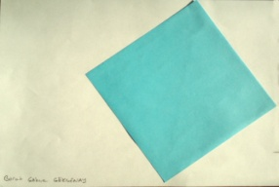

**23/09/2014**

* “Welcome” and nature of architectural education.
* Submission of problem
* Studio work
* Criticism

**26/09 2014**

* Theoretic discourse
* Criticism
* Studio work

**30/09/2014**

* Submission of final work

1. Section at 09:00am
2. Section at 14:00am)

* Introducing new assignment

**ASSIGNMENT I**

***“Putting two things together”***

(Figure-Ground Relationship)

**Problem:**

You are asked to put two things on the A4 paper. You are entitled to explain the reason and define the composition considering the things and the paper size.

**Stages of Progression:**

1. Explanation of the problem
2. Theoretical discourse
3. Performance and Discussion in class
4. Submission and Evaluation

**Due: 03/10/2014**

**Important Note:**

When we say “thing” we mean anything that exists,

to consist as a material for our senses and/or; for our mind;

also detected as an existence by thinking or observation

No “thing” can be observed without a ground to rest on.