**Hours:** 09.00 - 19.00 Tuesdays and Fridays (10 hrs per week)

**Instructors: 1. Section Zenep Onur, Ziya Tanalı, Gözdem Üner Tuğbay**

**2. Section Ziya Tanalı, Alper Gündüz, Oya Kuyumcu**

_________________________________________________________________________________

**Supply for the next studio time:**

* Colored or achromatic paper (if necessary)
* Cutting and pasting tools (no spray is permitted).
* Drafting & modeling tools
* Any other material found necessary by the student.

**Homework:**

1. Development and preparation of the assignment for criticism.

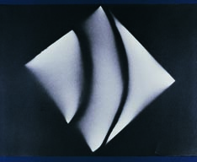

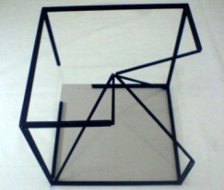

**30/09/2014**

* Theoretic discourse
* Submission of problem
* Studio work
* Criticism

**10/10 2014**

* Theoretic discourse
* Criticism
* Studio work

**14/10 2014**

* Criticism
* Studio work
* Criticism

**17/10/2014**

* Submission of final work

1. Section at 09:00am
2. Section at 14:00am)

* Introducing new assignment

**ASSIGNMENT II**

***“A whole is more than the sum of its parts”***

(position)

(parts & the whole)

**Problem:**

You are asked to design and build a 3-D composition to witness when parts come together can give a different message, more than its parts do.

This will be done by the repetition of the same geometric shape (like square, triangle, cube, circle etc., sizes may differ).

In each composition a single geometric form would be utilized (not less than only 5 triangles **OR** only 5 squares for example).

Material is free in the construction of geometric shapes. The shortest dimension of finished form shall not be less than 40 cm.

**Stages of Progression:**

1. Explanation of the problem
2. Theoretical discourse
3. Performance and Discussion in class
4. Submission and Evaluation

**Due: 17/10/2014**

**Important Notes:**

* Material is free