**Hours:** 09.00 - 19.00 Tuesdays and Fridays (10 hrs per week)

**Instructors: 1. Section Zenep Onur, Ziya Tanalı, Gözdem Üner Tubay**

**2. Section Ziya Tanalı, Alper Gündüz, Oya Kuyumcu**

_________________________________________________________________________________

**Supply for the next studio time:**

* Colored or achromatic paper (if necessary)
* Cutting and pasting tools (no spray is permitted).
* Drafting & modeling tools
* Any other material found necessary by the student.

**Homework:**

1. Development and preparation of the assignment for criticism.

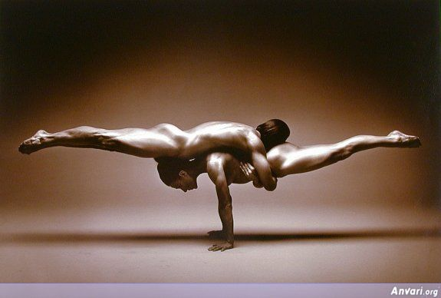

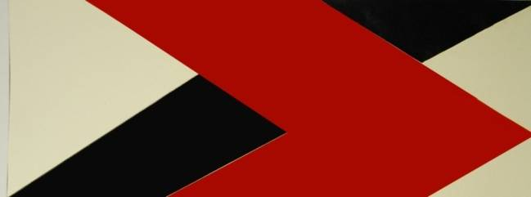

**17/10/2014**

* Theoretic discourse
* Submission of problem
* Sketch Problem

**21/10 2014**

* Theoretic discourse
* Criticism
* Studio work

**24/10 2014**

* Criticism
* Studio work
* Criticism

**28/10/2014**

* Submission of final work

1. Section at 09:00am
2. Section at 14:00am)

* Introducing new assignment

**ASSIGNMENT III**

***“Create an Asymmetric Balance by a 3D Composition”***

*(5. what is abstraction, the muse)*

(6. balance, harmony, symmetry, asymmetry)

**Problem:**

* You are assigned to compose a balance that is asymmetrical.
* Do not consider balance as the equality of the parts utilized.

**Stages of Progression:**

1. Explanation of the problem
2. Theoretical discourse
3. Performance and Discussion in class
4. Submission and Evaluation

**Due: 28/10/2014**

**Important Notes:**

* You must consider to utilize a new material that has not been used in your previous assignments.
* One of the measurements of the composition has to be at least 50 cm.