**Hours:** 09.00 - 19.00 Tuesdays and Fridays (10 hrs per week)

**Instructors: 1. Section Zenep Onur, Ziya Tanalı, Gözdem Üner Tubay**

**2. Section Ziya Tanalı, Alper Gündüz, Oya Kuyumcu**

_________________________________________________________________________________

**17/10/2014**

* Submission:

1. Section at 13:30 hours)
2. Section at 18:30 hours)

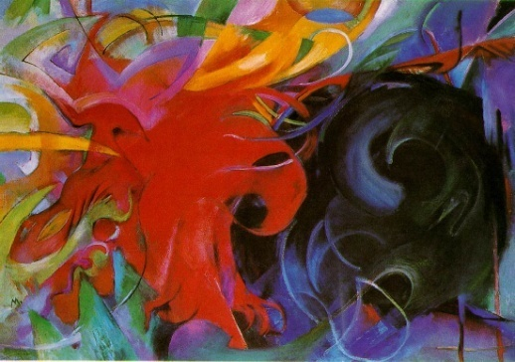

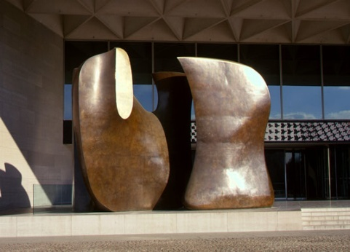

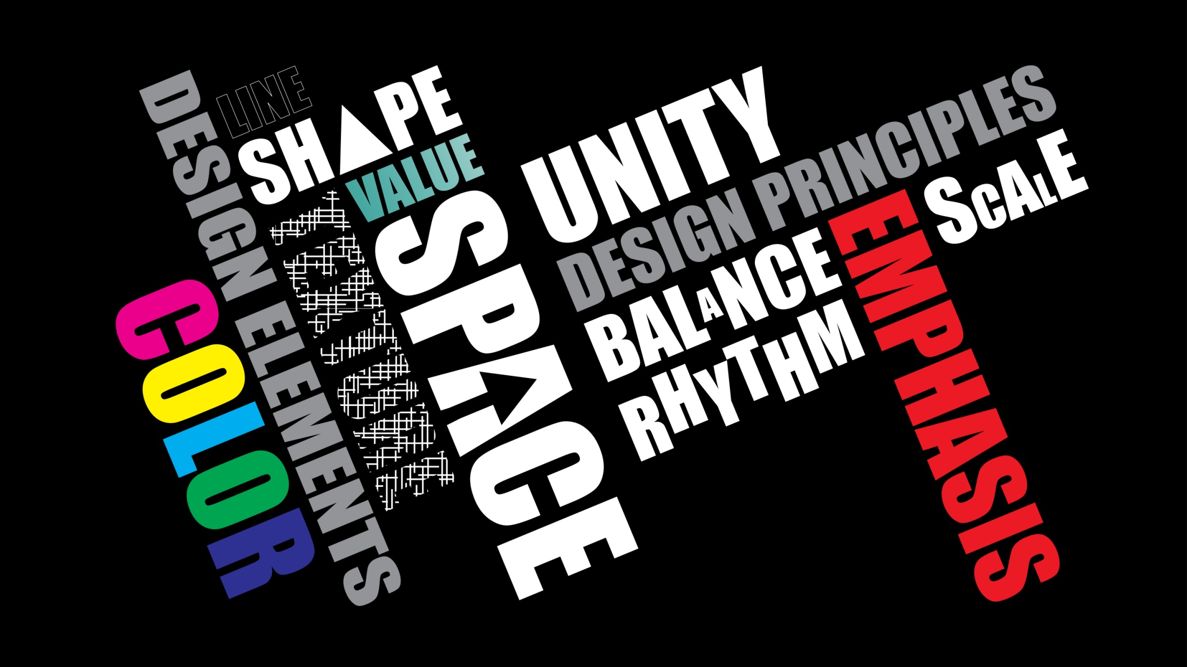

**Sketch Problem 01**

**Problem:**

Discuss the relation between objects and their relation to their context by choosing any artwork like a painting, a sculpture or a graphical design piece.

Resim, heykel ya da bir grafik tasarım ürünü üzerinden nesnelerin kendi aralarında ve içinde bulundukları ortamla olan ilişkilerini tartışınız

**Due: 17/10/2014**

1. Section between 10:30 - 13:30 hours)
2. Section between 15:30 - 18:30 hours)